ILLUSTRATED WALKTHROUGH FOR AUTODESK FUSION

Tube Shop
Design tools
Learn each Design tool by following a short exercise, checking the picture, then using the option table when you need more control.
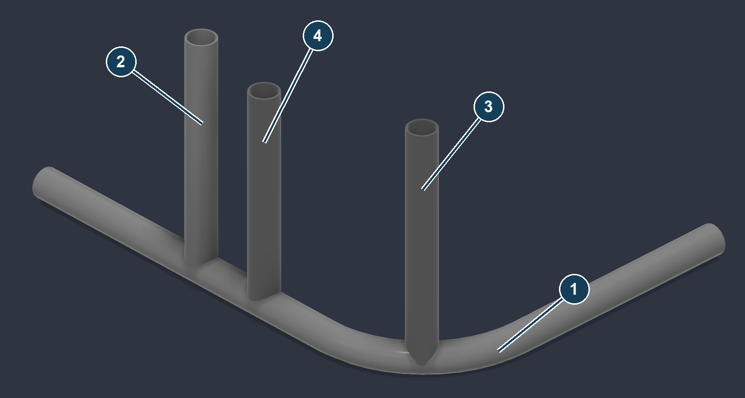
The main job: 1 H1 bent host, 2 I1 imported brace, 3 B1 bend branch, 4 B2 straight branch. Small point, sketch and scan exercises introduce the other tools.
This guide covers | What you get
All 11 Design tools | Where to open each tool, what to select, what to enter, and how to check or undo the result.
Two related die tools | Change tube die and Review bend dies, including their different scopes.
Every native option | Plain-language explanations, including options that appear only after a selection.

Version checked: Tube Shop 1.10.9 in Fusion 2706.1.14 on Windows. The original job walkthrough and its practice files are included.
How to read the pictures: All CAD pictures are genuine Fusion viewport captures. Numbered circles and captions were added. Native dialog capture failed, so the adjacent tables give the verified control labels; no dialog mockups are used.
Review edition: Some tools failed in the tested release. Their pages identify the stop and do not imply a completed result.

Find the tool you need
Open: Tube Shop palette → Actions → Design
Open the palette from SOLID → APEX DESIGN → Tube Shop. Imported tubes is a distinct subsection under Design. The two die tools are on the Dies tab.
Tool | Use it for | Page
Extract centerlines | A reference sketch from existing solids | 4
Reconcile imported points | Add point links to an imported tube | 5
Place points | Coordinates, mirrors, scan picks and tube stations | 6–8
Tube through points | Build a tube from ordered points | 9–10
Tube point coordinates | Move points and change their references | 11–12
Review host points | Choose what each point follows | 13–14
Update from points | Rebuild the connected geometry | 15
Tube anchors | Create reusable snap points on tubes | 16
Scan targets | Find centres in a scan mesh | 17–18
3D tube sketch | Draw and edit a spatial path | 19–21
Tubes from sketch lines | Turn a wireframe into tubes | 22–23
Change tube die | Replace a whole eligible tube’s stock and die | 24–25
Review bend dies | Assign or convert individual bends | 26–27

Visible references: Actions → Design → Show tube reference points displays saved tube drivers. Select a tube for numbered points; select a point to see its consumers. Hiding this display does not delete points.
Not available in this release: Tube boundaries and Generate tube route are disabled in the verified 1.10.9 installation. They are not steps in this guide.

Prepare the practice files
Extract the complete package. Work in a disposable copy. Type the unit suffix in with exercise values so a document using millimetres cannot silently change their meaning.
Practice path | Open or create
Main four-tube job | models/QS109_04_Point_built_branches.f3d. H1 is the bent host, I1 the imported coped brace, B1 the bend branch, and B2 the straight branch.
Imported geometry | models/QS109_Input.step. Check the 1.500 in outside diameter and the intended orientation before using imported tools.
Points and sketches | Start a new inch design for the exercise on page 6. Saved checkpoints DT01 through DT04 are in models/.
Scan centres | models/DT_Synthetic_balls_MM.stl. Import as millimetres. The three balls are synthetic practice geometry, each 1 in in diameter.

Use 1.500 in OD × 0.095 in wall for all tube exercises. The demonstration dies have centreline radii of 6 in and 4.5 in. A point at a bend corner is the intersection of the straight centreline legs; it is not on the rounded bend.
Die quantity | What it means
OD and wall | The tube cross-section. Wall must be positive and less than half the OD.
Die CLR | The radius of the tube centreline around the bend. It controls tangent positions and the room needed for a bend.
Calibration | Measured bender behaviour, such as springback and length corrections. Use a physical test bend for your stock and tooling; these files contain illustrative values only.

Die setup: Follow step 1 of the visual quick start before building. Review or create the DEMO ONLY dies in a separate library or disposable copy. Do not overwrite production calibration with these examples.
Choose a learning route: For a complete fabrication job, follow the included quick start in its original order. Use this guide beside it when you need the controls explained.
Use the full job walkthrough for die calibration, coping and export. Open the visual quick start
IMPORTED TUBES

Extract centerlines
Open: Tube Shop palette → Actions → Design → Imported tubes → Extract centerlines
Use this when you need a sketch reference from an existing round tube. The command leaves the original solid in place.
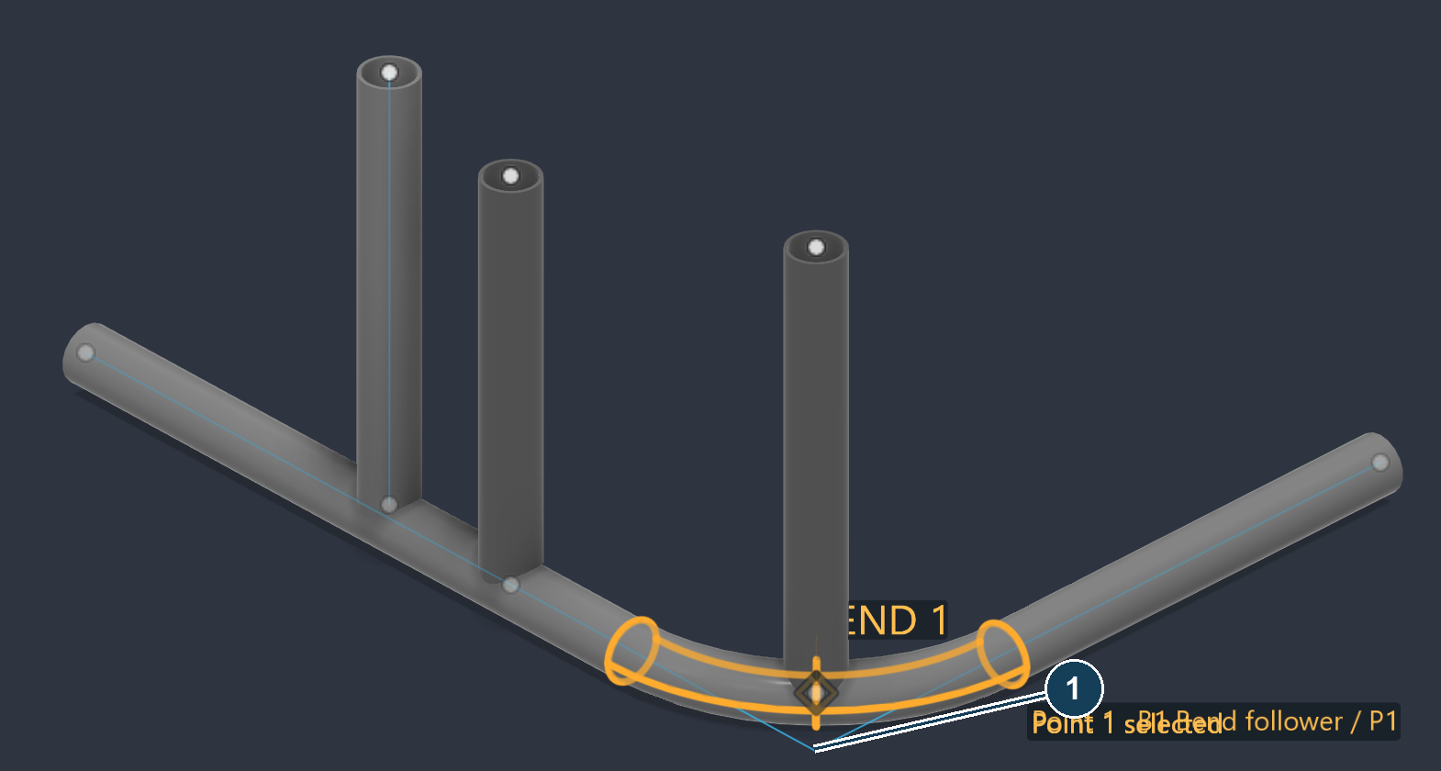
Verified extraction reference in the later four-tube checkpoint. The sketch shows the straight centreline layout and sharp bend intersections beside the solids.
1. Open a copy of QS109_Input.step and identify H1 Bent host.
2. Open Extract centerlines. In Tubes, select H1’s body or a face belonging to it. Add I1 only if you want that tube included.
3. Review the selection and click Extract. Show the resulting sketch and compare it with the tube.
Option | How to use it
Tubes | Select the intended tube bodies or their faces. There are no OD, wall, die or radius inputs in this command.

Check: Confirm the original bodies remain and the reference sketch follows their runs. Extraction creates independent sketch geometry; it does not attach the imported solid to editable drivers.
Common mistake: Using an extracted sketch to build another tube creates another body. Use Reconcile imported points if the purpose is to retain and link the existing solid.
Limits: Coped or trimmed ends do not guarantee recovery of the original pre-cut stock endpoints. If a body is refused, retry with one supported tube at a time.
Cancel and undo: Cancel before Extract. After extraction, use Fusion Undo to remove the added sketch.
IMPORTED TUBES

Reconcile imported points
Open: Tube Shop palette → Actions → Design → Imported tubes → Reconcile imported points
Use reconciliation to give an imported tube source-point links while keeping its existing solid and measured bends. Do not follow it with Tube through points for the same tube.
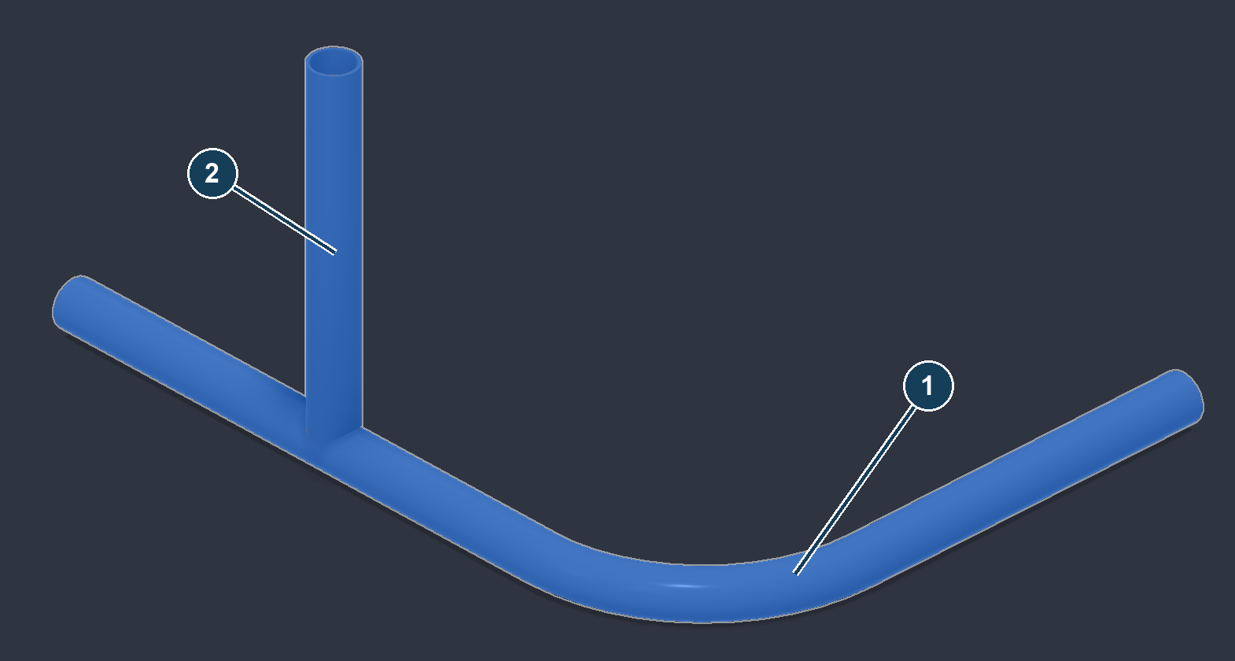
Attempted selection: 1 is H1, the bent host; 2 is I1, which already has a coped lower end. Reconciliation did not complete in this test.
1. Open QS109_Input.step and confirm scale. Start with one tube in Imported tubes so any refusal identifies the problem clearly.
2. Review the command’s description, then click Create point links.
3. If it succeeds, inspect the source points and confirm the body count, bend radii and existing cut remain unchanged. Continue with point and host review, not another tube build.
Option | How to use it
Imported tubes | Select the imported tube bodies to reconcile. There are no replacement radius or stock-size controls here.

Supported intent: Coped end cuts must remain within verified straight end regions. Openings, tabs and cuts reaching into bends may be refused.
Observed stop: H1 and I1 were blocked by “An analytic spine cannot carry both butt closure and a junction-return end relation.” A clean restart did not resolve this. No successful reconciliation or preserved-cut update is claimed.
Recovery: Cancel and retain the imported model. For the verified point-edit exercise, open QS109_04_Point_built_branches.f3d and use its existing B1/B2 points.
Cancel and undo: Cancel before creating links. After a successful operation, use Fusion Undo and check the original solid is still present.
EXERCISE 1 COORDINATES AND MIRRORS

Place points
Open: Tube Shop palette → Actions → Design → Place points
Create a known set of points before building a tube. Start a new inch design. This exercise creates three points and their reflected partners.
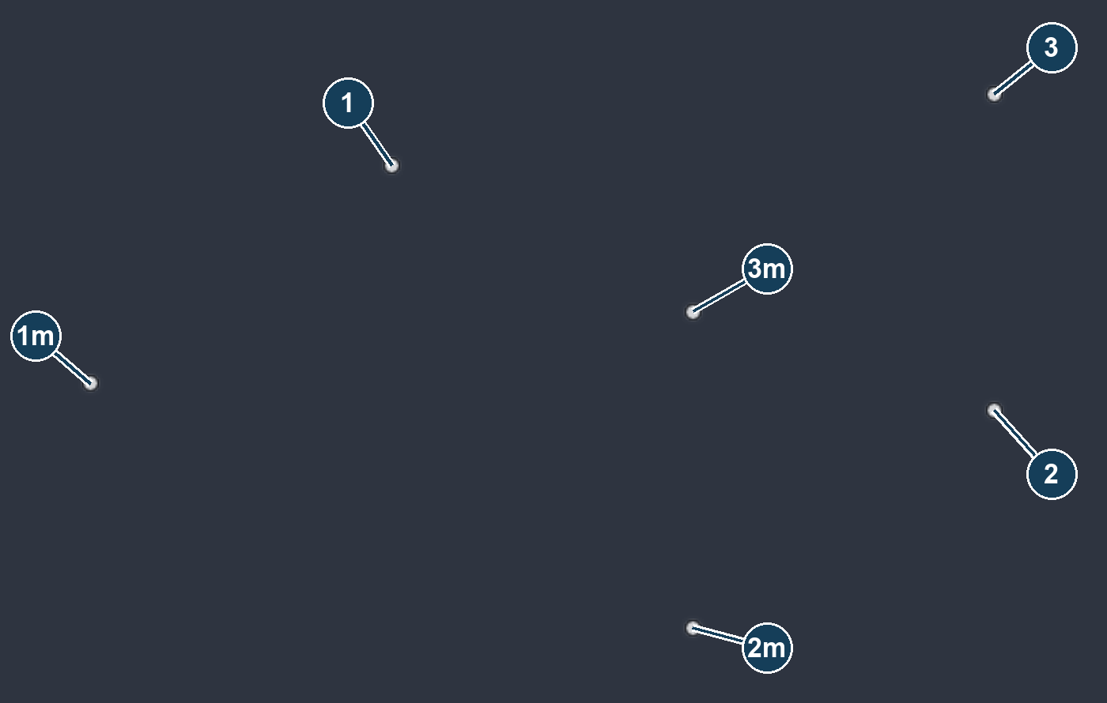
Verified six-point result. 1–3 are the typed points at Y = +8 in. 1m–3m are their partners at Y = −8 in.
1. Leave Measure from at the design origin. Click Add point row three times.
2. Enter the following offsets. Set each row’s Mirror to Y and keep Ref at the origin.
Row | X | Y | Z | Mirror
1 | 0 in | 8 in | 0 in | Y
2 | 24 in | 8 in | 0 in | Y
3 | 24 in | 8 in | 12 in | Y

3. Inspect both sets of live points, then click Keep points. The saved checkpoint is DT01_Mirrored_points.f3d.
Check: There should be six distinct points. Changing the sign of Y reflects across the origin XZ plane; X and Z stay the same.
Cancel and undo: Cancel removes the current live draft. After Keep points, use Fusion Undo to remove this placement operation.
COORDINATES AND REFERENCES

Place points options
A row’s X, Y and Z are offsets from that row’s Ref. They are absolute design coordinates only when Ref is the origin.
Control | Meaning and practical use
Pick reference point | Starts reference picking. Choose a sketch point, construction point or vertex in the intended occurrence.
Measure from / Reference point | The reference used for newly added rows. Picked references enter the list as R1, R2 and so on. Existing rows keep their own reference.
Reset reference to origin (0,0,0) | Makes new rows measure from the design origin. Check existing rows’ Ref entries separately.
X / Y / Z | Signed offsets in the design’s length units. Use explicit units such as 8 in. Negative values go in the negative axis direction.
Ref in each row | Selects that row’s reference from the saved reference list. A reference choice affects where that row’s offsets land.
Mirror in each row | Dash means no twin. X reflects across YZ, Y across XZ, and Z across XY. Reflection is about the design origin plane, not about the row’s reference point.
Add point row | Adds another live point row, using the current reference. It does not create a tube.
Remove selected row | Removes the selected table row. If no row is selected, the last row is removed.
Keep points | Commits the live point set. Inspect the points before keeping them.

Reference example: if R1 is at (10, 0, 0) in, a row of (4, 0, 12) in lands at (14, 0, 12) in. Pick another reference only when the next group of points should measure from that location.
Avoid a common mirror error: Y means “reverse the Y coordinate,” not “mirror across the XY plane.” In the exercise, +8 becomes −8. A point on the chosen origin plane does not give a separated twin.
Reference versus host: Measuring from a picked reference and explicitly following a host tube are different operations. Use Review host points to inspect the saved relationship; do not infer host following from a visually coincident point.
SCAN PICKS AND TUBE STATIONS

Place points on existing geometry
These optional groups add points to the same table. Open a group only when you need that input method.
Pick on scan / mesh | Meaning and practical use
Mesh face | Click the scan at the required location. A click adds a row; the picker clears so you can click again.
Snap to the tube’s centre | Off captures the clicked scan skin. On attempts to infer the section centre from the local mesh and the section size below.
Tube section | Round, Square or Rectangular. Choose the actual section before snapping.
Tube OD / Width (or side) / Height | Enter the known outer section dimensions. Round uses OD; square uses its side; rectangular uses width and height. Do not enter wall thickness in these fields.

Point along tube | Meaning and practical use
Tube | Pick a recognised tube whose centreline will be used.
Sweep | Move the station along the centreline, including bends. It is a length from the identified end A, not a percentage. The readout also reports the distance from the other end.
Add point here | Adds the displayed station as a row and keeps the tube selected. Repeat Sweep → Add point here for more stations.
Locked row coordinates | A committed analytic station can follow the host tube. Its XYZ/Ref fields are locked; later use Tube point coordinates → Detach from host if you need independent coordinates.

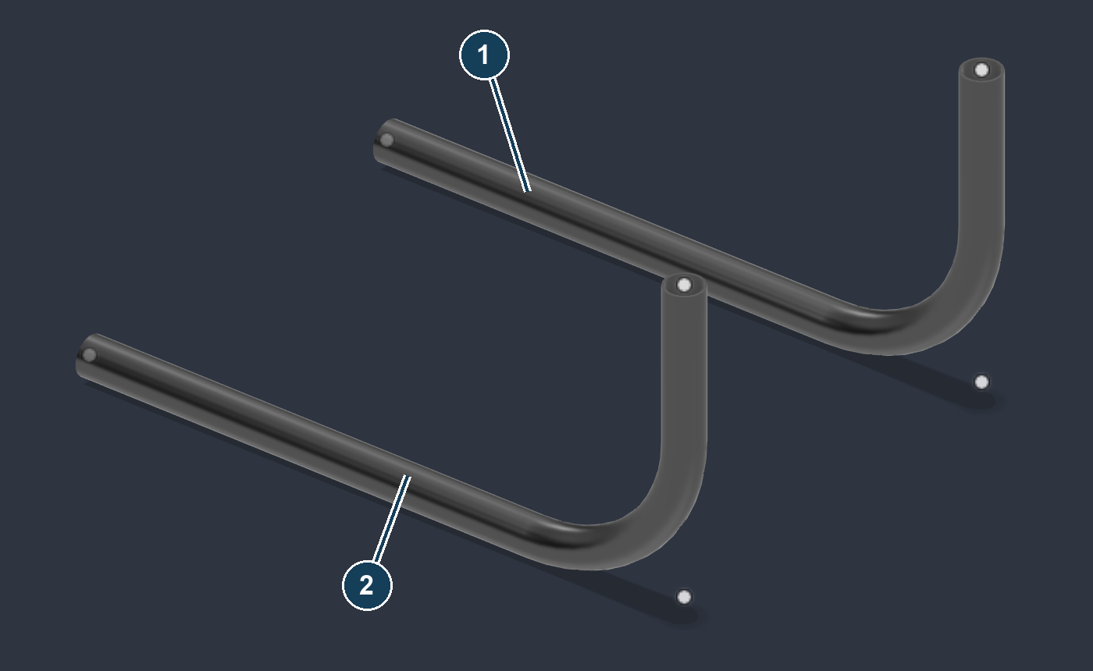
These newly built tubes were used for the station check. The station operation failed before it produced a usable following point.
Observed stop: Point along tube hit the same analytic-spine error on the new pair. Its controls were inspected, but host-station creation and subsequent following are unverified.
Check a scan pick: Inspect the point from more than one view. A centre snap is an estimate from the available mesh; the skin pick is not automatically the tube centreline.
Cancel and undo: Cancel discards this placement draft. Use Undo after Keep points. For scanning a whole set of balls or tube sections, see Scan targets.
EXERCISE 2 BUILD THE MIRRORED PAIR

Tube through points
Open: Tube Shop palette → Actions → Design → Tube through points
Open DT01_Mirrored_points.f3d, or continue after page 6. Use the three original points in the correct run order.
Verified result: 1 is the +Y tube; 2 is its mirrored partner. Each has one 90° bend at 6 in CLR.
1. In Points, in run order, pick 1 → 2 → 3 using the point labels on page 6. Do not alternate between the original and mirrored sides.
2. Choose DEMO ONLY 1.5 x .095 R6 in Bending die. Check Tube OD = 1.5 in, Wall thickness = 0.095 in, and Fillet corners at die CLR on.
3. Open Loop and mirror. Leave Close the loop off. Turn Build the mirrored twin too on and choose XZ (side-to-side, Y).
4. Inspect the bend preview, click Build tube, then dismiss the completion message. The saved result is DT02_Point_tubes.f3d.
Check: There should be two new hollow solids and one rounded corner per tube. The run’s sharp corner point sits at the theoretical leg intersection, outside the rounded centreline.
Cancel and undo: Cancel before building. After the operation, use Fusion Undo and confirm both newly built bodies are removed.

Tube through points options
Control | Meaning and practical use
Points, in run order | Select sketch points, construction points or vertices in the intended travel order. Two points make a straight member. Add corner points in sequence for bends.
Bending die | Chooses the bend tooling. The die seeds OD and wall, which remain editable. “None” leaves the picked straight-line corner layout; it does not invent a bend radius.
Tube size preset | Sets an available stock size. Choose Custom to type OD and wall yourself. Preset material labels identify the catalogue entry; they do not prove your actual material or calibration.
Tube OD | Outside diameter. Recheck it after changing the die or size preset.
Wall thickness | Radial wall thickness. It must be greater than zero and less than half the OD.
Fillet corners at die CLR | Rounds sharp corners using the selected die’s calibrated centreline radius. The adjoining straight legs need enough room for the tangent setbacks.
Close the loop | Joins the last point to the first. Needs at least three points. Closed-loop geometry does not have the same open-path Update from points support.
Build the mirrored twin too | Builds a second tube reflected across an origin plane. This is separate from displaying or creating mirrored point rows.
Mirror across | XZ reverses Y; YZ reverses X; XY reverses Z. Pick the plane by the coordinate you need to reverse.
Bend check / preview | Read the bend-fit feedback before building. A failed fillet or short leg is a reason to change the layout, not to assume the expected bend was made.

Avoid duplicates: Page 9 uses the original points once and the builder’s twin option once. Do not then build the mirrored point set again.
If a bend does not fit: Increase the straight-leg spacing, choose a compatible smaller radius, or revise the path. Inspect the result count and any fillet failures in the completion message.
Links: Open point-built tubes retain source identities for later updates. Do not delete their driving points as a way to clean the viewport; hide the source sketch instead.
EXERCISE 3 MOVE A BRANCH ENDPOINT

Tube point coordinates
Open: Tube Shop palette → Actions → Design → Tube point coordinates
Use the main assembly: QS109_04_Point_built_branches.f3d. This verified exercise moves B2 independently; it does not test host following.
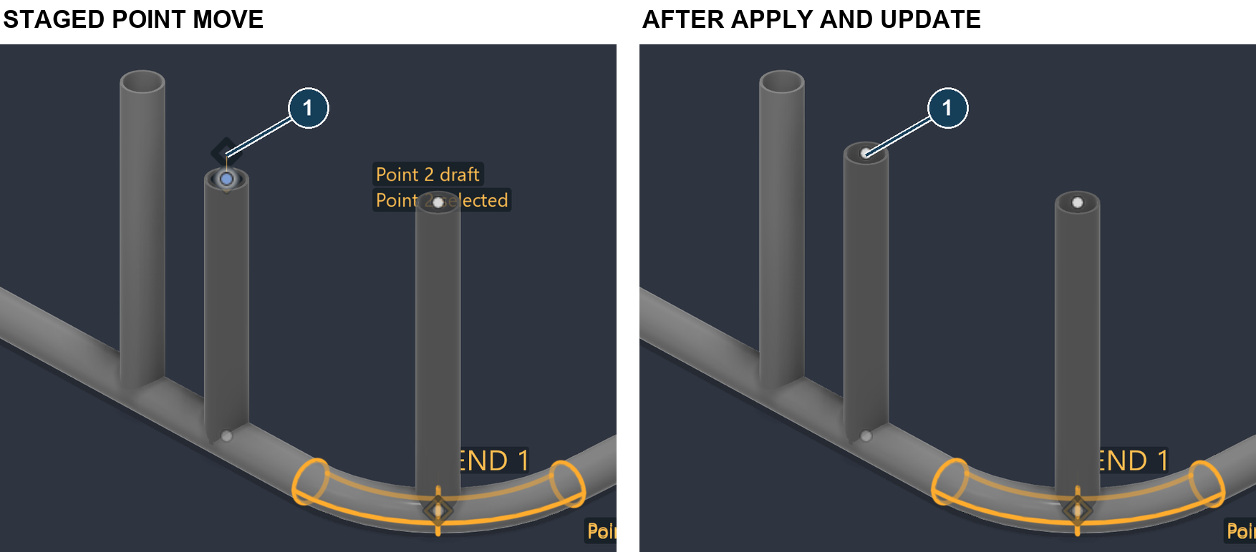
Verified staged and applied views. B2’s upper point moves from Z = 10 in to Z = 11 in; the connected straight tube is rebuilt.
1. First open Review host points. For all four B1/B2 source points, choose Fixed in space, click Stage this choice, then Apply choices. This checkpoint precedes those fixed choices.
2. Open Tube point coordinates. Choose the source entry identified by B2 / P2, or pick B2’s upper source point. The generic “Point 2” number can differ between sessions.
3. Keep X = 14 in and Y = 0 in. Set Z = 11 in. Leave Preview drafts on and check the highlighted point.
4. Turn Update tubes on Apply on, then click Apply. Alternatively leave it off, Apply the point edit, close the dialog, and run Update from points separately.
Check: B2’s upper end reaches Z = 11 in. B1 stays at its original height. The earlier verification retained the B2 source identities and die assignment.
Preview is a draft: A moved preview point is not proof that the solid was updated. Compare the actual tube after Apply and the connected update.
Cancel and undo: Cancel abandons staged edits. Use Fusion Undo after Apply; if point application and Update were separate operations, inspect and undo the required steps. Undo/Redo was checked on this exercise.

Point coordinate options
Control | Meaning and practical use
Pick point | Select the source point in the model to locate its row. Use the visible tube/point label to avoid selecting the other branch.
Source point | Choose a saved driver by its tube and station label. Numbered labels are a convenience; durable point identities are stored with the model.
X / Y / Z | Absolute design-root coordinates, not offsets from a reference as in Place points. Enter explicit units.
Point reference | Keep current reference preserves it. Follow selected tube assigns the selected host. Detach from host makes the point independent so its coordinates can be edited.
Host tube | Appears for Follow selected tube. Select the intended driving tube, then inspect the staged relationship before Apply.
Rotate selected point / Axis | X, Y or Z is the axis of rotation in the design frame.
Angle | The requested rotation angle. Positive and negative values rotate in opposite directions; check the preview before applying.
About | Design origin or another listed source point is the pivot. This is different from the selected point you are moving.
Stage rotation | Places the rotated coordinates into the draft. Review XYZ; the button is not the final Apply.
Preview drafts | Shows staged changes in the viewport. Turning it off does not commit or discard the values.
Update tubes on Apply | When on, applies point changes with the connected tube update. When off, applies points first; run Update from points to rebuild the tubes.
Apply | Commits the current staged choices. Resolve any validation or reference error before continuing.

Rotation example: An independent point at (14, 0, 0) in rotated +90° about design Z and the origin should be reviewed at (0, 14, 0) in before Apply. This is a coordinate example, not a second tested branch movement.
When editing is unavailable: The point may be host-linked, mirrored or otherwise constrained. Inspect Point reference and the reason shown. Do not detach a deliberate relationship merely to make a field editable.
CHOOSE WHAT EACH POINT FOLLOWS

Review host points
Open: Tube Shop palette → Actions → Design → Review host points
Use this to review relationships deliberately. A point near a tube may be fixed, unassigned or linked; proximity alone is not a relationship.
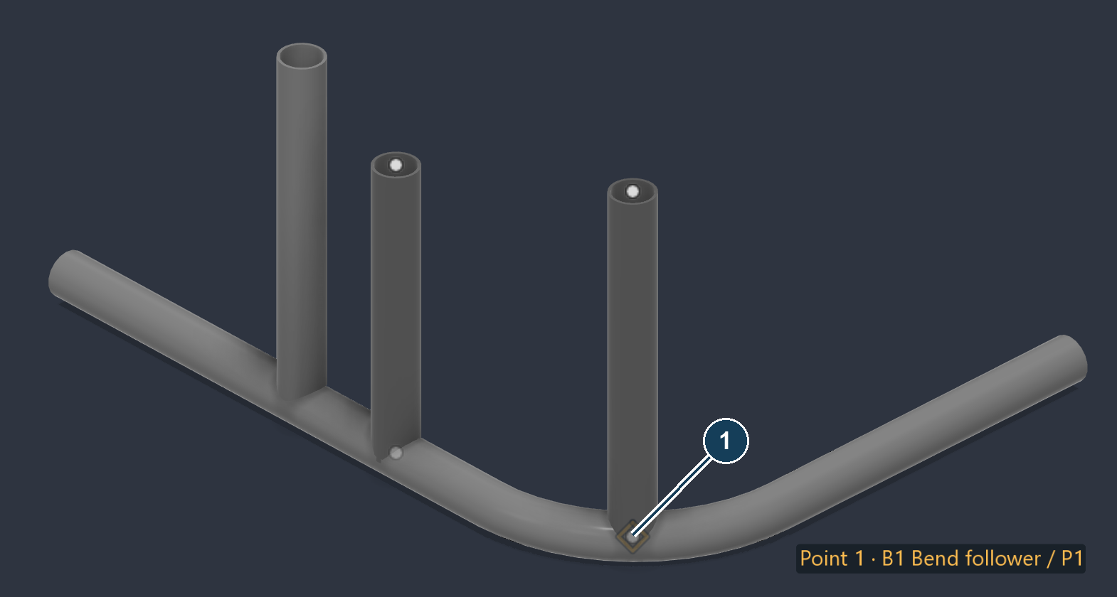
Reviewing the branch source points in the main assembly. Host candidate analysis was blocked in this test; an attached B1 result is not shown.
1. Open QS109_04_Point_built_branches.f3d. Start with Search radius = 0.125 in and select the B1 / P1 lower point in Source point.
2. Read the current reference, point location and candidate details. Check the highlighted point against B1’s lower end on H1’s bend.
3. For a supported host result, choose the correct candidate in Point follows and click Stage this choice. To use the independent exercise instead, choose Fixed in space and Stage this choice.
4. Review Queued choices, then click Apply choices. Assigning a relationship alone does not necessarily move the point; inspect it and use the required connected update.
Observed stop: Candidate analysis returned the analytic-spine error. Fixed choices were applied successfully. B1 following H1’s bend and its response to a radius change remain unverified.
Check: Read the saved relationship after Apply. A marker sitting on H1 in the picture is not evidence of a saved H1 link.
Cancel and undo: Cancel discards queued choices. After Apply choices, use Fusion Undo and recheck the relationship.

Host review options
Control | Meaning and practical use
Search radius | The neighbourhood used to find possible host centreline references. It is a length in the document units. Use a small radius appropriate to your model; 0.125 in is the example, not a universal tolerance.
Source point | Selects the point being reviewed. Read its consuming tube/station, current host and any assembly-order information.
Point follows | Keep current reference makes no new choice. Fixed in space explicitly keeps the point independent. Candidate entries identify eligible hosts or reference positions.
Stage this choice | Adds the selected relationship to the queue. This does not apply it yet.
Queued point | Selects a queued change for review or removal.
Remove queued choice | Drops only the selected draft choice. It does not remove the source point.
Discard all choices | Clears the draft queue while leaving the saved relationships unchanged.
Stage unique recommendations | Queues only unambiguous recommendations. Existing links, fixed decisions and already queued choices are preserved; ambiguous or unverified cases require review.
Reload points | Refreshes the point and candidate inventory after model changes. Review the resulting list and queue again.
Apply choices | Saves the queued relationships after validation. Read any rejected choices instead of assuming the entire list was linked.

Nearby capture: A supported nearby centreline reference can retain a measured offset. Capture does not mean “snap the point onto the surface.” Inspect the stored reference and position.
Assembly order: Recommendations use valid hosts installed earlier than every tube driven by the point. Missing order, ties or uncertain geometry need a deliberate choice.
Dependency cycles: A host cannot depend back on the branch it drives. For example, H1 → B1 → H1 is a cycle. Correct the host choice or keep the appropriate point fixed; do not increase the search radius to bypass the dependency.
If the wrong tube appears: Reduce the search radius, select the source point again and read the candidate labels. The correct host is determined by design intent, not simply by the nearest surface.

Update from points
Open: Tube Shop palette → Actions → Design → Update from points
Run this after changing saved source points when the tubes have not already been updated. It updates managed tube geometry and connected relationships, then replays affected recorded copes.
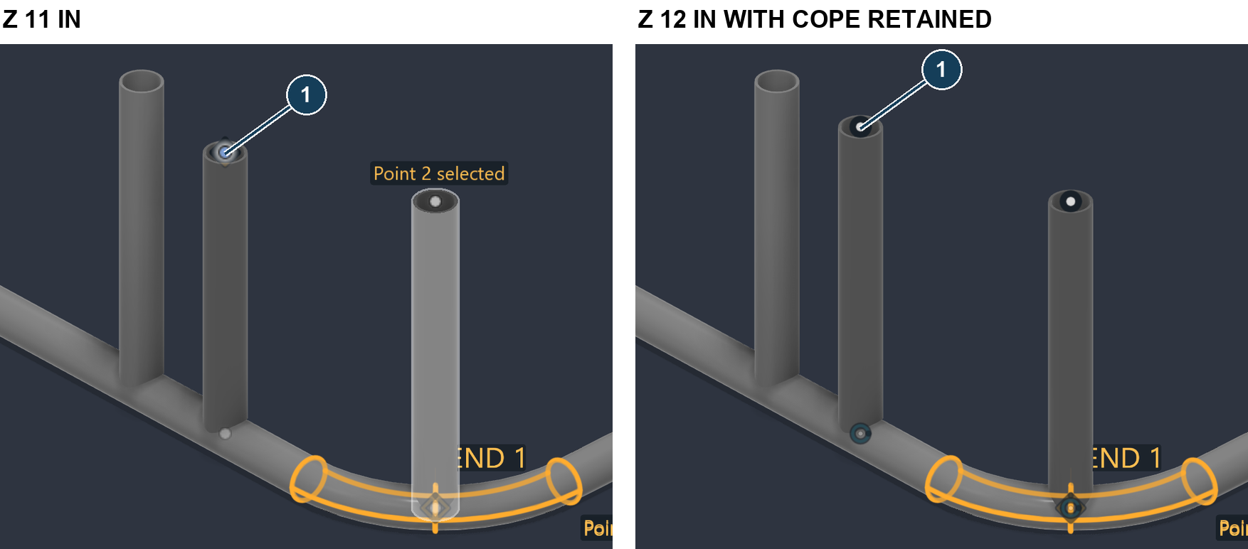
Verified separate cope-update check: B2 went from Z = 11 in to Z = 12 in and one recorded cope was reapplied. The saved ordinary final job was returned to Z = 11 in.
1. After a point edit, close the editing dialog. Check that you are in the intended design and that the source sketch still exists.
2. Click Update from points. There is no separate options dialog. Read the result or error message before making another edit.
3. Inspect the moved endpoint, bend shape and every affected joint. Confirm the intended tube name, die and point relationship remain attached to the rebuilt tube.
What controls this tool | What to know
Saved point and tube links | These define which managed tubes can be rebuilt. Selecting an arbitrary unlinked solid does not make it point-driven.
Connected changes | Expect dependent geometry and affected recorded copes to be included. Do not assume the operation is limited to the visually selected body.
Unchanged or unsupported paths | A matching tube can be reported unchanged. Read any refusal for lost references, unsupported paths or geometry that cannot be rebuilt.

Avoid manual duplicate rebuilds: If Update tubes on Apply already completed the connected update, another click may correctly report no changes.
Cancel and undo: This is an immediate command, so there is no draft Cancel button. Use Fusion Undo after completion and inspect the restored joints. If it fails, keep the original geometry and resolve the reported cause.

Tube anchors
Open: Tube Shop palette → Actions → Design → Tube anchors
Tube anchors is intended to create a reusable snap scaffold from visible recognised tubes. It runs immediately and has no option fields.
Input for the anchor check: two newly built point tubes. The visible dots are their existing source points. No new anchor result was produced.
1. Show only the intended tube bodies. Hide unrelated tubes before running the command.
2. Click Tube anchors. Read the reported number of anchor points, recognised tubes and any warnings.
3. On a successful result, show the Tube anchors sketch. Inspect endpoint, bend tangent, bend midpoint/apex and sharp intersection points before using them in a new path.
Behaviour | What to expect on supported geometry
Scope | Visible tubes that the recogniser can read.
Anchor identity | Each anchor belongs to its own host tube. Coincident joint positions can contain separate anchors for separate hosts.
Re-run | Refresh after moving tubes. Existing valid anchor identities are intended to be retained so consuming paths can keep the chosen reference.

Observed stop: The new pair returned zero anchors and the analytic-spine error for both tubes. Anchor creation and following are not verified in this guide.
Recovery: Use the known source points from DT01 for the point-building lesson. Do not interpret the existing six dots as successful Tube anchors output.
Cancel and undo: There is no draft dialog. Use Fusion Undo after a successful run. Deleting a scaffold used by other tubes can break their references; hide it when you only want a clear view.
EXERCISE 4 FIND THE BALL CENTRES

Scan targets
Open: Tube Shop palette → Actions → Design → Scan targets
This tool converts scan targets into sketch points. The exercise uses a known synthetic mesh so its result can be checked exactly; it is not a scanner accuracy test.
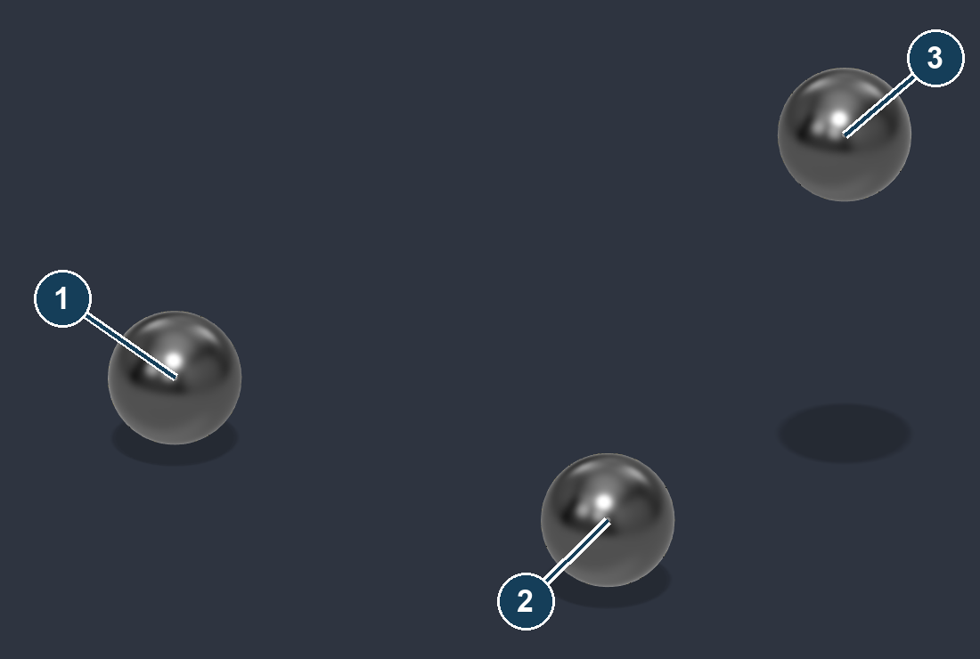
Verified centres from the synthetic 1 in balls: 1 = (0, 0, 0), 2 = (4, 0, 0), 3 = (4, 3, 2) in.
1. In a new design, insert DT_Synthetic_balls_MM.stl as mm. Check a ball is 1 in across.
2. Open Scan targets. In Scan (mesh body), select the mesh. Choose Sphere (printed ball) and Ball diameter = 1 in.
3. Click Create points. Read the number found, then show the Scan targets sketch and compare the centres from multiple views.
4. Inspect the saved example DT05_Scan_target_centres.f3d. Its three centre coordinates match the caption. These points can be selected by Tube through points.
Verification method: The live native controls were inspected. The released scan command’s build routine found all three centres with no warnings; the blocking completion dialog was not used for this API-driven capture.
Cancel and undo: Cancel before Create points. Use Fusion Undo after creation. Sphere mode replaces the previous Scan targets point set; protect any existing work before running it again.

Scan target options
Control | Meaning and practical use
Scan (mesh body) | Select the imported scan mesh, not a BRep tube solid. Tube-section mode needs a live mesh body.
Target | Sphere (printed ball), Round tube section, Square tube section or Rectangular tube section.
Ball diameter | The actual target diameter, not its apparent size on screen. Used for Sphere mode.
Tube OD | The actual outside diameter for a round tube section.
Section width | The outer width, or side dimension for a square section.
Section height | The second outer dimension for a rectangular section.
Click the tube | In section mode, click the mesh at each station where a centre is needed. Inspect the fitted preview for each click.
Forget the clicks | Clears the section-pick list so you can start again. It does not delete the imported scan mesh.
Replace the previous scan points | Section-mode choice: on replaces the prior scan point set; off adds to it. In Sphere mode the native command replaces the prior set.
Read an STL file instead | Sphere mode can read a file directly at creation time. Choose it if you are not selecting a mesh already in the design.
STL file units | mm, cm, in or m. These are the source file’s coordinates, not the preferred display units. Choosing the wrong one scales the input incorrectly.
Scan requirements | Expandable guidance for target visibility, mesh quality and fitting. Read it before using noisy or incomplete data.

Two different workflows: Sphere mode searches for balls of the known diameter. Tube-section mode fits centres where you click; choose the section and enter its dimensions first.
Check failed fits: Read the count and any “no usable section” warning. A missing point is not an acceptable hidden approximation. Retry at a better scan region or improve the scan.
Limits of this example: Only synthetic sphere centres were measured here. Round, square and rectangular scan fitting controls were inspected, but real-scan fitting accuracy and physical placement are unverified.
EXERCISE 5 DRAW A SPATIAL PATH

3D tube sketch
Open: Tube Shop palette → Actions → Design → 3D tube sketch
Draw a centreline path in space, then finish it as a sketch. Start a new inch design, or hide the earlier practice pair so its points do not confuse picking.
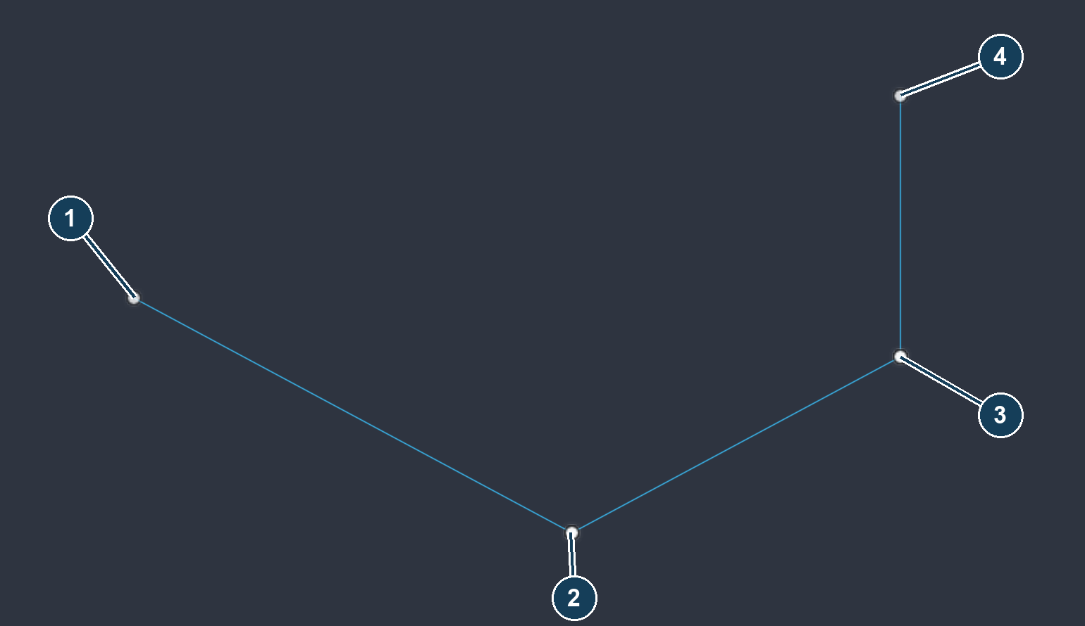
Isolated Fusion view of the same four path coordinates. 1 is the start; 2 and 3 are bend intersections; 4 is the raised endpoint. Lines alone are not a tube.
1. Choose Drawing space. Click Start at origin to place point 1.
2. Set Plane / axis = X axis and Length lock = 24 in. Click toward +X, review the point at (24, 0, 0) in, then Add point.
3. Set Y axis, lock 18 in, click toward +Y, check (24, 18, 0) in and Add point. Then use Z axis, lock 12 in, click toward +Z, check (24, 18, 12) in and Add point.
4. Set Sketch name = 3D practice frame. Turn Open tube builder after Finish off for this lesson, then Finish sketch.
Check: There should be three joined straight segments, with a total of four corner/end positions. The direction of a length lock still comes from your pick. The saved checkpoint is DT03_3D_sketch.f3d.
Cancel and undo: Undo last point changes the active draft. Cancel abandons it. After Finish sketch, use Fusion Undo to remove the saved sketch.

3D sketch picking options
Control | Meaning and practical use
Pick from | Drawing space uses the chosen drawing plane or axis. Scan / model surface picks a visible surface position as a reference.
Plane / axis | View plane follows the camera’s drawing plane. XY, XZ and YZ constrain the next point to that plane through the current anchor. X, Y or Z restrict the segment to one axis.
Length lock (0 = free) | Sets the distance from the current anchor. Zero permits free length. Choose a direction away from the anchor; a nonzero length alone cannot choose direction.
Snap to points | Allows picks to use available points or draft geometry. Check the snap label before accepting the point.
Start at origin | Places the initial anchor at design (0,0,0). It is only available when appropriate for the current draft.
Selected point / X Y Z | Appears after staging or selecting a point. Edit the design-root coordinates before accepting it. Active plane/axis and length locks still constrain the result.
Add point / Apply move | Adds a staged endpoint, or moves a selected existing draft point. Moving a shared point changes its connected legs.
Pick another position | Discards the current staged position so you can pick again.
Branch from this point | Uses the selected existing draft point as the start of another run. It accepts the selected-point adjustment before branching.
Connect to this point | Connects the current run to the selected existing point when there is a valid current anchor and a distinct target.

Watch the button label: The action changes with the state: starting a run, adding an endpoint and moving a shared point are different operations. Read the status text and the Selected point coordinates.
Locks reset: The length lock clears after a point is accepted. Re-enter it for the next constrained segment. If XYZ will not move freely, check Plane / axis before retrying.
A branch is a junction: Branches can cause the later tube builder to split the wireframe into separate members. Review the member count, not just the visible line count.

3D sketch setup and runs
Control | Meaning and practical use
Surface offset / Offset | Appears for a staged surface reference. Moves the intended centreline away from the picked skin by the entered distance.
Direction | Toward view or +X, −X, +Y, −Y, +Z, −Z. Toward view depends on the pick view; an axis direction uses the design frame.
Tube setup / Saved die | Select the intended tooling for bend preview and the following build. No die / straight members is suitable for the line-only lesson, not a verified bent-tube solution.
Outside diameter / Wall thickness | The intended stock dimensions for preview and the tube builder. Confirm them when changing tooling.
Open tube builder after Finish | On finishes the sketch and opens Tubes from sketch lines. Off saves the sketch so you can inspect it first.
New run / branch | Ends the current run and starts another. Use Branch from this point when the new run must share an existing junction.
Undo last point | Steps back in the active draft. If there is a staged point, it is discarded before an accepted point is removed.
Close loop | Connects the current run back to its start when valid. Closed loops do not support the same Update from points path as open members.
Mirror | Off, Across YZ, Across XZ or Across XY. Reflects the wireframe across a design-origin plane; check for coincident or duplicate paths.
Sketch name | Name for the saved sketch. Use a meaningful name so it is easy to select in the tube builder.
Finish sketch | Saves accepted geometry; a valid pending point can be included. Resolve any current point error first.

Surface reference is not clearance: Picking a scanned surface does not automatically put the tube centreline outside it. Apply the intended offset and inspect the whole tube envelope from multiple views.
Before finishing: Read the segment/member count and the support feedback. A visible tube preview does not guarantee that every member supports later point-driven updates.
What was verified: The X/Y/Z locked line path and saved sketch were exercised. Surface-offset picking, branching, closing and mirror options were inspected; each combination was not independently built.
EXERCISE 6 BUILD THE SPATIAL TUBE

Tubes from sketch lines
Open: Tube Shop palette → Actions → Design → Tubes from sketch lines
Open DT03_3D_sketch.f3d. Select the named three-segment wireframe; keep the earlier point-tube exercises hidden.
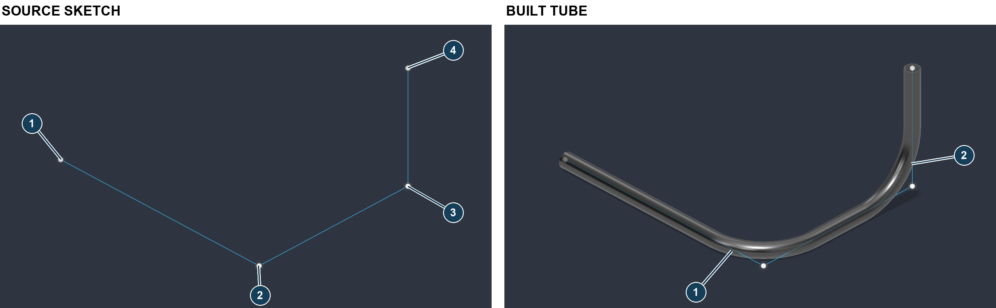
Isolated Fusion views of the path and a copy of the verified result: one hollow tube with two 6 in CLR bends.
1. Choose 3D practice frame in Wireframe sketch. Leave Sketch curves (viewport) empty to use the whole sketch.
2. Choose DEMO ONLY 1.5 x .095 R6. Check Tube OD = 1.5 in and Wall thickness = 0.095 in.
3. Turn Fillet sharp corners at die CLR on. Review the selected sketch and the reported members, then click Build tubes.
4. Inspect the two corners and open ends. Show the source sketch temporarily if you need to compare tangent positions.
Verified result: The released build routine reported one body, two fillets, one linked tube and no warnings. DT04_Sketch_tubes.f3d contains the result. This does not prove that every later edit to this path will rebuild.
Check: There should be one visible tube for this continuous non-branching run. Extra members usually indicate separate runs, a junction, duplicate curves or an unintended selection.
Cancel and undo: Cancel before Build tubes. After building, use Fusion Undo and confirm the source sketch remains available as expected for the chosen build.

Sketch tube builder options
Control | Meaning and practical use
Wireframe sketch | Choose the sketch containing the intended tube centrelines. The list can include sketches marked “no lines”; those are not a usable line path for this tool.
Sketch curves (viewport) | Optional curve selection limits the build to the selected member chains. Ensure the selected curves belong to the intended sketch; clear them when you want the whole sketch.
Tube size preset | Choose a listed stock size, or Custom to type dimensions. Recheck the actual OD and wall after changing presets.
Tube OD | Outside diameter of the swept hollow section.
Wall thickness | Wall thickness of the section. Must be positive and smaller than half the OD.
Bending die | Sets the available bend tooling. None keeps the corner layout as drawn; it does not choose a bend radius for you.
Fillet sharp corners at die CLR | Rounds sharp eligible corners using the chosen calibrated CLR. Existing drawn arcs require their own compatibility review; do not assume this setting replaces every arc.
Build tubes | Builds the recognised member chains as new bodies. Read body count, fillet count, warnings and link support in the result.

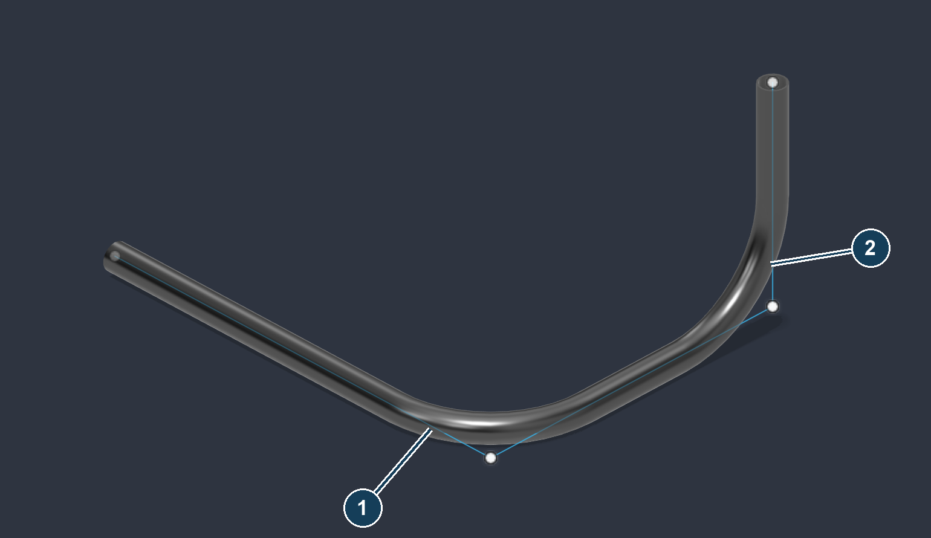
The two numbered corners were both rounded in the practice result. The straight source intersections remain useful for checking the path.
Source behaviour: A Tube Shop point scaffold is copied for its build so source identities can remain available. Ordinary sketch geometry follows the builder’s applicable path; keep a disposable source copy before experimenting with fillets.
Junctions and loops: Junctions split members. Open supported source paths can retain point links; closed or unsupported geometry may build without Update from points support. Read the completion feedback.
WHOLE TUBE STOCK AND TOOLING

Change tube die
Open: Tube Shop palette → Dies → Change tube die
This command plans a replacement of an eligible whole tube using a saved die’s stock dimensions and CLR. Use Review bend dies when the change should concern individual bends.
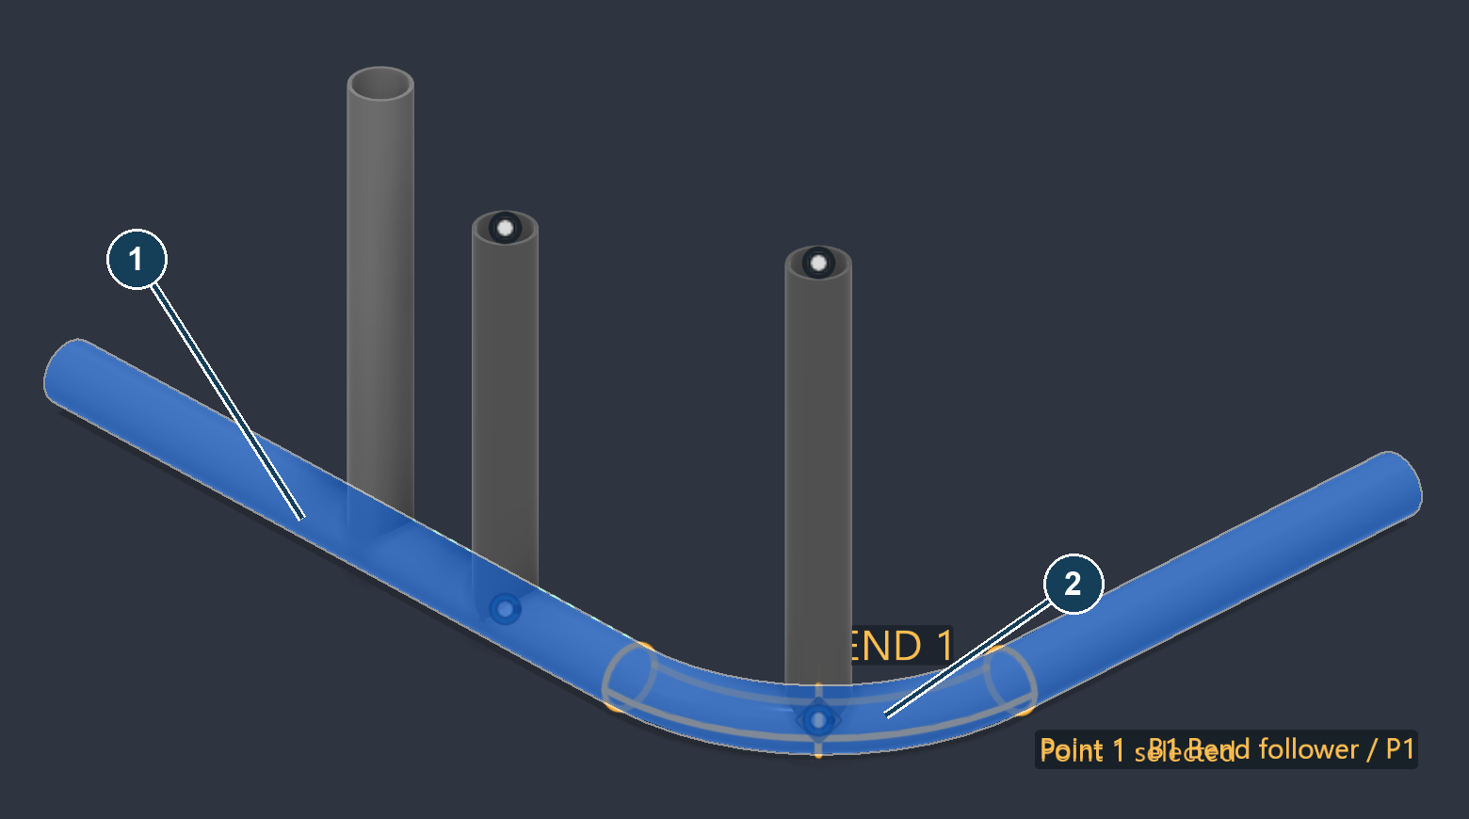
Attempted review of H1: 1 is the selected host; 2 is its existing bend. The requested R4.5 replacement was blocked, so this remains the original R6 geometry.
1. Use a disposable copy of QS109_Input.step or the main assembly. Select H1 in Tubes.
2. Choose DEMO ONLY 1.5 x .095 R4.5 in Saved die. Read Target stock and bends and the proposed change report.
3. Review Editable points and any Follow hosts choices. If the plan is valid, Apply performs the replacement; inspect the full tube and all connected joints afterward.
Observed stop: H1’s plan returned the analytic-spine error and Apply was unavailable. There is no verified whole-tube R4.5 result in this package.
Separate restriction: The new mirrored point tube was also checked. The command refused it because Tube through points or a cage already drives it, and directed the change back to that existing build workflow.
Recovery: Keep the original tube. Do not delete its point links to force this tool to accept it. Review the responsible build or use an eligible per-bend operation.
Cancel and undo: Cancel keeps the current geometry. After a supported Apply, use Fusion Undo and inspect stock, bend and connection restoration.

Whole tube die options
Control | Meaning and practical use
Tubes | Select the bodies whose whole-tube stock and tooling should change. Begin with one tube so the report is easy to verify.
Saved die | Chooses the target OD, wall and calibrated CLR together. The plan readout shows these dimensions; they are not separate editable fields in this dialog.
Editable points | Requests editable source points for the eligible replacement. Review any restriction from existing Tube through points or cage ownership.
Follow hosts (optional) | Expands the three host choices below. Use only when the intended driving tube relationships are clear.
End A host | Assigns a host for end A. Check A/B labels; they are tube path ends, not necessarily left and right on screen.
End B host | Assigns a host for end B.
Intersection host | General host for eligible intersection points. Explicit End A or End B choices take precedence for those ends.
Plan and history readouts | Review change count, source size, target size, editable points and host information. A direct-model design may need history enabled when Apply runs.
Apply | Commits only a valid current plan with an actual change. Re-selecting a die that already matches can correctly produce no change.

Host requirements: Host relationships need editable points and valid independent hosts. A selected replacement body cannot serve as its own host.
Physical implications: Changing to a saved die can change stock size as well as radius. Recheck clearance, adjoining fit, existing cuts and available tooling before using the result for fabrication.
Do not confuse the tools: Whole-tube replacement and per-bend assignment have different scopes. Review bend dies filters compatible stock for individual bends; this tool takes the replacement stock from the chosen die.
Verification status: Control labels and both refusals were checked live. A successful replacement, changed stock and host-following replacement were not demonstrated.
INDIVIDUAL BENDS AND RADIUS CHANGES

Review bend dies
Open: Tube Shop palette → Dies → Review bend dies
Use this to assign tooling to a measured bend or request a compatible radius conversion. A matching assignment and a changed-radius conversion are different outcomes.
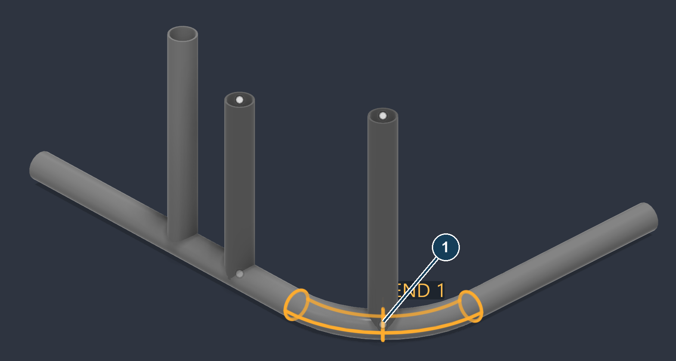
H1’s original 6 in CLR bend in review. A matching R6 assignment was verified; the attempted conversion to R4.5 was blocked.
1. Open the main assembly. Select H1 in Tubes (optional), leave Include assigned bends on, and choose H1 Bent host · bend 1 in Bend.
2. For an assignment-only check, choose the compatible R6 demonstration die. Click Stage this bend and review the queue.
3. For a radius-change test instead, choose the compatible R4.5 die and click Stage this bend again. Leave Preview queued geometry on; inspect the new queued choice and any error.
4. Click Apply choices only for a valid reviewed queue. Check the resulting measured CLR and all attached branches, then run the required connected update if it has not already completed.
Observed result: Matching R6 assignment succeeded. Changed-radius conversion returned the analytic-spine error. No before/after R4.5 geometry or verified B1 follow movement is supplied.
If a replacement cannot fit: A larger tangent setback can consume the available straight leg. Change the path or use suitable tooling; do not treat a rejected preview as a completed conversion.
Cancel and undo: Cancel discards queued edits. After Apply choices, use Fusion Undo and inspect the bend and dependent geometry.

Bend review options
Control | Meaning and practical use
Tubes (optional) | Limits the review to selected tube bodies. With no selection, review the available model inventory shown by the command.
Include assigned bends | Shows bends that already have an assignment so you can review or change them.
Bend / Saved die | Selects the bend and a die compatible with its OD and wall. Check the measured radius and the chosen target radius.
Stage this bend | Adds the current bend/die choice to the queue.
Preview queued geometry | Shows the proposed queued result where it can be generated. A preview error must be resolved before applying.
Focus selected bend | Moves the view to help inspect the chosen bend. Recheck selection before staging.
Stage matching bends | Queues listed bends with the same mode, OD, wall and measured CLR as the selected bend. The chosen die must be applicable to every match.
Stage all eligible bends | Queues all bends in the current scope to which the chosen die can apply, including eligible assigned bends. This can exceed the currently filtered list; inspect the queue.
Queued choices / Remove queued choice | Selects a draft item, or removes only that item. The saved model remains unchanged until Apply.
Discard all choices / Reload tubes | Clears the draft queue, or refreshes the model inventory. Review the resulting list before continuing.
Create die from this bend | Creates an unsaved die draft from the measured bend. Finish and save it in Dies, then reopen review to assign it. It does not calibrate the bender or silently replace an existing draft.
Choose driving hosts / Linked point | Appears when point decisions are required. Select the affected point before choosing its relationship.
Follows / Stage point choice | Choose a valid host or Keep fixed, then stage that point decision. Resolve every required choice before Apply choices.
Apply choices | Validates and commits the reviewed queue. Inspect each changed bend and its connected tubes and cuts.

Bulk choices need review: Stock compatibility alone does not prove that a new radius fits every layout. Keep the first exercise to a single bend.
Calibration: A die draft made from modeled geometry contains measured geometric inputs, not physical springback or test-bend calibration.

When a tool stops
Symptom | What to check or do next
No candidate host or analytic-spine error | Cancel the affected host/reconcile/radius operation. Keep the original tube. This release failed those checks in the documented examples; repeated Apply is not evidence of success.
Point moves but the solid stays put | Check Update tubes on Apply. If it was off, close the point dialog and run Update from points. Confirm the tube actually has saved point links.
Wrong side mirrored | Identify the coordinate to reverse: X → YZ, Y → XZ, Z → XY. Origin planes stay fixed even when Place points uses another reference.
A value changes by 25.4 | Check file and field units. Type in with inch exercise values; import the synthetic STL as mm.
Short leg or rejected bend | Check the required tangent room and the selected CLR. Revise the path or choose fitting tooling; inspect the completion warning count.
Too many tubes after building | Look for a second build of the same path, a selected mirrored point set plus a mirrored-twin build, or junctions splitting a sketch into members.
Cannot change a tube’s whole die | A Tube through points or cage source may already own the tube. Return to that build workflow; do not remove provenance to bypass the refusal.
Scan points missing or misplaced | Check target kind, known outer dimensions, STL units and the fit report. Inspect centres from multiple views before using them as drivers.
3D point will not move where expected | Check active plane/axis, length lock, snap label, selected-point state and the surface offset direction.

Before continuing to fabrication: verify the actual solids, stock dimensions, radii, point relationships and joints. A saved assignment, draft preview or completion count does not replace geometric inspection.
For coping, optional tabs and the separate developed-geometry and experimental ZX export routes, continue with the full job walkthrough. Open the visual quick start
Retained limits: The original guide’s steep-angle tab example is rejected. The experimental ZX output was not validated in TubePro or on a machine. No physical calibration, fit or structural strength is claimed.

Practice files and verification
File in models | What it contains
DT01_Mirrored_points.f3d | Six committed points. Use it as the starting point for Tube through points.
DT02_Point_tubes.f3d | The two matching bent point tubes, 1.5 × 0.095 in, with 6 in CLR.
DT03_3D_sketch.f3d | The named 3D practice frame sketch. Earlier point exercises are hidden.
DT04_Sketch_tubes.f3d | One visible spatial tube with two rounded corners. Earlier point tubes are hidden.
DT05_Scan_target_centres.f3d | Synthetic ball mesh and three detected centre points.
DT_Synthetic_balls_MM.stl | Known synthetic 1 in balls, stored in millimetres. This is not a real scan.
QS109 files | The unchanged main assembly, STEP input, point-update, coping and optional-tab checkpoints from the full job walkthrough.

Evidence | Result
Release and controls | Installed 1.10.9; pinned release commit 7b069981. Native input inventories were read live for all 11 dialog tools; immediate tools were checked against released code.
New demonstrated geometry | Six mirrored points, two point-built tubes, the locked 3D sketch, one tube from that sketch, and three synthetic scan centres.
Blocked or restricted | Reconcile, host analysis, tube stations, anchors and H1 radius replacement remain blocked by the analytic-spine error. Whole-tube die replacement rejects point/cage-driven tubes.
Not independently demonstrated | Every option combination, real scan accuracy, successful host following and radius conversion, and physical fabrication.
Source and recovery | Live records, control inventories, screenshot hashes and authoring files are included. Original settings, shop and die file hashes were unchanged; user documents were restored.

Pictures and evidence: Numbered screenshots preserve the full 1800 × 1125 captures. The guide uses crops and labelled pairs. Capture labels explain whether a picture is an input, a draft, a verified result or a blocked review.
Method: Some geometry was exercised through the released command’s API/build routine. The sketch/build comparison was photographed in an isolated Fusion display copy of the verified body and the same four path coordinates, to remove unrelated overlays. All images are actual Fusion captures.

